Nicolet FEAR Chain Tensioning Method

Problem: Our team has had trouble tensioning chain in the past on our robot so that the chain does not skip/break.

This is a method we developed November & December 2016.

Working Criteria for System:
- Works for multiple chain sizes & lengths
  - 25 & 35 chain
  - Lengths that would be on robot
- Ease of use
  - Under 15 min. of training
- Low cost
  - Less than $30
- 2 part system
  - Off-robot measuring technique
  - On-robot device

Research
Reason for Research | Source | Information
Products we could buy | https://www.mcmaster.com/#chain-tensioners/=15etjis | Bought idlers are VERY expensive
Techniques that exist | http://www.hardcoresledder.com/forums/350-mini-sled-forum/424039-chain-tensioner.html | 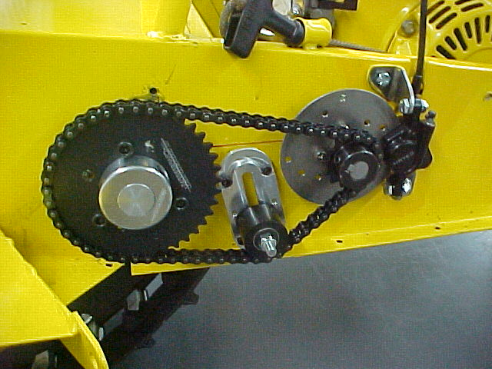
 | https://www.chiefdelphi.com/media/photos/26057 | 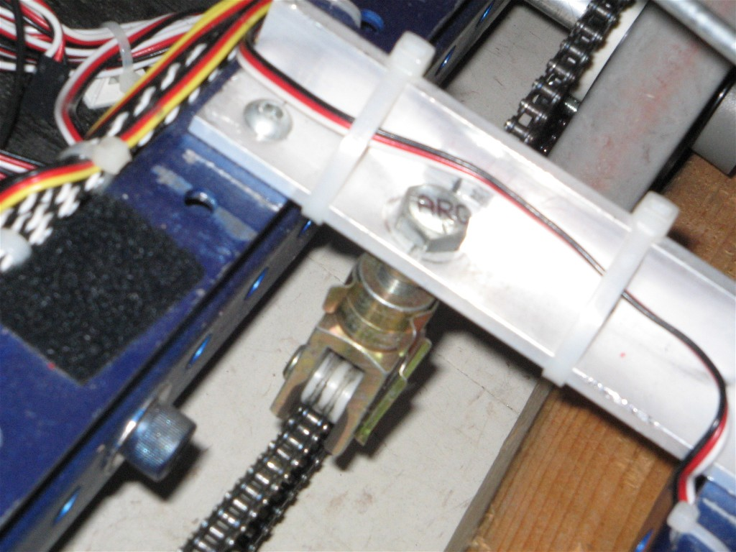
 | https://www.chiefdelphi.com/forums/showthread.php?t=61099 | 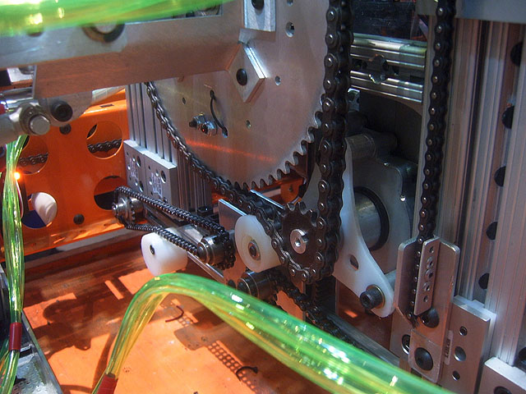  Off-center hole in HDPE idler, rotate to tension
 | https://www.chiefdelphi.com/forums/showthread.php?t=102013 | PVC idler or sprocket idler
 | Shared PDF (“Chain Manufacturer's’ Manual”) in Chain Tensioning folder | Where idlers can be added
Companies that make idlers | http://www.botlanta.org/converters/dale-calc/sprocket.html
 | http://www.brewertensioner.com/products.html
General knowledge about robotics | http://hcwilson.weebly.com/uploads/3/8/4/6/38463501/frc_guide_-_arpan_rao.pdf | See link for information & tips on everything robotics from another FRC team
Chain length calculators | http://www.botlanta.org/converters/dale-calc/sprocket.html
 | http://www.islandpondrailroad.com/chain.htm
Plastic for idler | http://www.vanderveerplastics.com/compare-materials.html?sel1=abs-machined-parts&sel2=hdpe | ABS v. HDPE
 | https://en.wikipedia.org/wiki/Acrylonitrile_butadiene_styrene | ABS
 | http://www.makerfarm.com/index.php/hardware/delrin-wheels-idlers.html | Delrin
 | http://www.rccrawler.com/forum/tools-procedures/128834-cutting-delrin.html | How to cut delrin
 | https://www.mcmaster.com/#standard-acetal-homopolymer-rods/=15bavkq | McMaster - Carr: Delrin
 | https://www.mcmaster.com/#hdpe/=15bavur | McMaster - Carr: HDPE
 | https://www.mcmaster.com/#polyamide/=15bau0f | McMaster - Carr: Polyamide
How to break & add chain | http://www.hardcoresledder.com/forums/350-mini-sled-forum/424039-chain-tensioner.html | Video tutorial

Adding Chain:
Use math equation
- http://www.botlanta.org/converters/dale-calc/sprocket.html
- http://www.islandpondrailroad.com/chain.htm

We used these equations to find the number of chain links for axles that are 10.5 in. apart. The length was 1-2 links off. Use the math equation as an approximation and add/subtract links as necessary.

Tensioning Chain:

Idea 1: Spring Loaded Idler

CAD & Drawing:
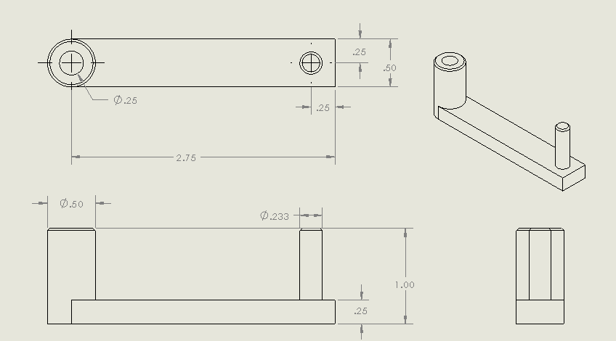

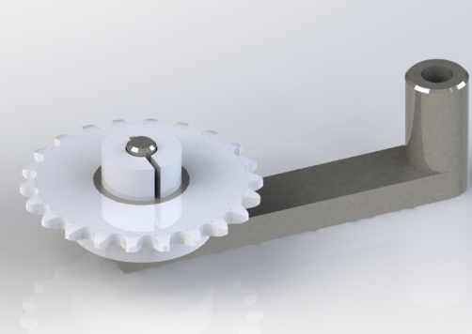

Pictures of Manufactured Part:
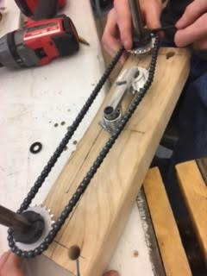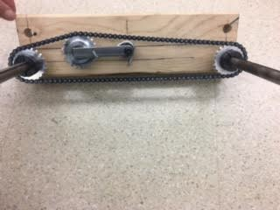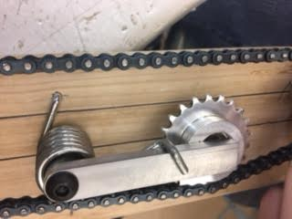

Materials:
From McMaster Carr:
- $5.48 / ½ ft. Low-carbon steel bar, 2.5in. / arm = $2.25 each
- $3.80 ea. ¼ in. 303 Stainless Steel Shaft Collar
- Spring still requires further research, but is estimated around $5 (Spring in prototype was taken from an old motor)
From Amazon:
- $4.76 / 5 pc Miniature ball bearing = $1 each
From Andymark:
- $16.00 ea. 22 tooth hubbed 25 sprocket

Process:
- Manufacture steel part with CNC or mill
- Boar out hole in sprocket with CNC or mill so that bearing can be press fit into it
- Press fit bearing into sprocket
- Put sprocket on arm of steel part and lock with shaft collar
- Put spring on and attach to frame

Idea 2: Plastic Delrin Idler

CAD & Drawing:

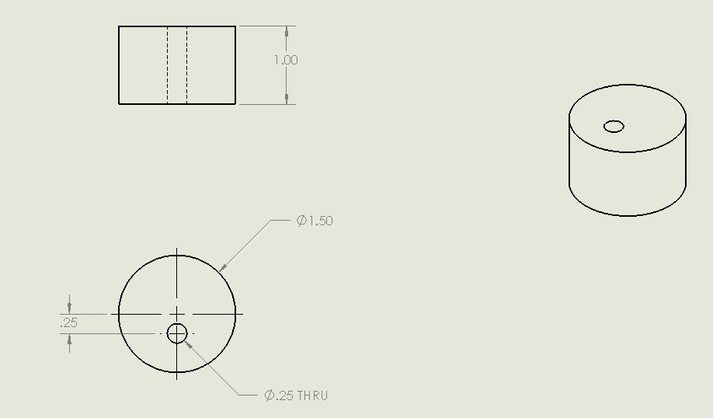

Pictures of Manufactured Part:
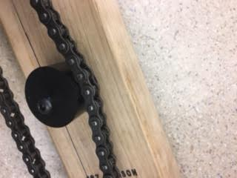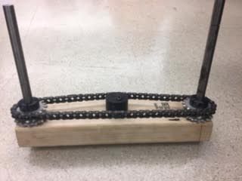

Materials:
From McMaster Carr:
- $10.37 Wear- and Water-Resistant Delrin® Acetal Resin (1.5 in. diameter, black), 1 in. per device
- ¼ 20 bolt and nut

Process:
- Cut delrin to 1 in. long with vertical band saw
- Drill hole with mill

Decision Matrix

Criteria | Works for 25 & 35 chain | Would work for lengths that would be on robot | Ease of use (amount of time to train to use) | Cost per 1 device | Time to make | Time to install | Certifications required to make | Quality of tensioning | Totals
How to measure | Prototype | Prototype | Talk to someone not on chain tensioning team and see if they understand, time how long to explain  1 = more than 10 min.  2 = 3 - 10 min.  3 = up to 3 min. | Add costs of parts  1 = more than $10  2 = up to $10  3 = Materials we have | Time how long to make  1 = 20 min. Or more  2 = 10 - 20 min.  3 = 10 min. Or less | Time how long to install  1 = 20 min. Or more  2 = 10 - 20 min.  3 = 10 min. Or less | 1 = Advanced zip ties  2 = Intermediate zip ties  3 = Basic zip ties | Not able to test - would need prototype able to move (not enough time to test)
Weights: | 3 | 3 | 3 | 3 | 1 | 2 | 2 | 3
Spring Loaded Idler | 3 (9) | 3 (9) | 3 (9) | 2 (6) | 1 (1) | 2 (4) | 1 (2) |  | 40
Plastic Delrin Idler | 3 (9) | 3 (9) | 3 (9) | 2 (6) | 3 (3) | 3 (6) | 1 (2) |  | 44

1=bad 3=good

Conclusion:
- These designs have not been tested on a moving prototype, so more testing would need to be done before using them on a robot
- We can combine the designs into a delrin idler on the spring system

